Java , Design Pattern Important Interview Questions
Java :

map() | flatMap()
The function passed to map() operation returns a single value for a single input. | The function you pass to flatmap() operation returns an arbitrary number of values as the output.
One-to-one mapping occurs in map(). | One too many mapping occurs in flatMap().
Only perform the mapping. | Perform mapping as well as flattening.
Produce a stream of value. | Produce a stream of stream value.
map() is used only for transformation. | flatMap() is used both for transformation and mapping.

Q) difference between executorservice.submit and execute

The submit() can accept both Runnable and Callable task but execute() can only accept the Runnable task.

The submit() method is declared in ExecutorService interface while execute() method is declared in the Executor interface.

The return type of submit() method is a Future object but return type of execute() method is void.

public <T> Future<T> submit(Callable<T> task) {
if (task == null) throw new NullPointerException();
RunnableFuture<T> ftask = newTaskFor(task);
execute(ftask);
return ftask;
}

public <T> Future<T> submit(Runnable task, T result) {
if (task == null) throw new NullPointerException();
RunnableFuture<T> ftask = newTaskFor(task, result);
execute(ftask);
return ftask;
}

How to print even and odd numbers using threads in java
package org.arpit.code2master;
public class PrintEvenOdd implements Runnable{

public int MAX=20;
static int num=1;
int remainder;
static Object lock=new Object();

PrintEvenOdd(int remainder)
{
this.remainder=remainder;
}

@Override
public void run() {
while (num < MAX) {
synchronized (lock) {
while (num % 2 != remainder) { // wait for numbers other than remainder
try {
lock.wait();
} catch (InterruptedException e) {
e.printStackTrace();
}
}
System.out.println(Thread.currentThread().getName() + " --> " + num);
num++;
lock.notifyAll();
}
}
}
}
Create main program as below to execute.

package org.arpit.code2master;
public class PrintEvenOddThreadMain {

public static void main(String[] args) {

PrintEvenOdd runnable1=new PrintEvenOdd(1);
PrintEvenOdd runnable2=new PrintEvenOdd(0);

Thread t1=new Thread(runnable1,"Thread 1");
Thread t2=new Thread(runnable2,"Thread 2");

t1.start();
t2.start();
}
}
https://www.geeksforgeeks.org/print-even-and-odd-numbers-in-increasing-order-using-two-threads-in-java/

Write code to solve the produce consumer problem in Java?
Write code to implement blocking queue in Java?

Externalizable vs Serializable:
Parameter
Serializable
Externalizable

Marker interface:
It is marker interface. You don’t have to provide implementation of any method.
Externalizable is not marker interface, you have to override writeExternal and readExternal method.

Control:
Serializable interface has less control over serialization process and it is optional to override readObject and writeObject.
Externalizable interface has more control over serialization process and it is mandatory to override writeExternal and readExternal.

Performance:
JVM uses reflection to perform serialization in the case of Serializable interface which is quite slow.
Programmer have to implement readExternal and writeExternal methods but it relatively results in better performance

Supersedes:
NA
If you implement Externalizable interface and provide implementation of readExternal and writeExternal then it supersedes readObject and writeObject methods in that class. It is due to the fact that Externalizable extends Serializable interface.

Constructor called during Deserialization:
Default constructor is not called during Deserialization process.
Default constructor is called during Deserialization process.

https://java2blog.com/how-hashmap-works-in-java/
https://java2blog.com/java-string-interview-questions-and-answers/
https://java2blog.com/java-multithreading-interview-questions-and-answers/
https://java2blog.com/java-exception-handling-interview-questions/
https://java2blog.com/java-serialization-interview-questions-and-answers/
https://java2blog.com/restful-web-services-interview-questions/
https://java2blog.com/java-coding-interview-questions/
https://java2blog.com/spring-interview-questions-and-answers/
https://java2blog.com/hibernate-interview-questions-and-answers/

Why String is declared final or immutable in java? =>https://www.journaldev.com/802/string-immutable-final-java

Different ways to create objects in Java
As you all know, in Java, a class provides the blueprint for objects, you create an object from a class. There are many different ways to create objects in Java.
Following are some ways in which you can create objects in Java:
- Using new Keyword : Using new keyword is the most basic way to create an object. This is the most common way to create an object in java. Almost 99% of objects are created in this way. By using this method we can call any constructor we want to call (no argument or parameterized constructors).
- Using New Instance : If we know the name of the class & if it has a public default constructor we can create an object –Class.forName. We can use it to create the Object of a Class. Class.forName actually loads the Class in Java but doesn’t create any Object. To Create an Object of the Class you have to use the new Instance Method of the Class.
// Java program to illustrate creation of Object
// using new Instance
public class NewInstanceExample
{
String name = "GeeksForGeeks";
public static void main(String[] args)
{
try
{
Class cls = Class.forName("NewInstanceExample");
NewInstanceExample obj =
(NewInstanceExample) cls.newInstance();
System.out.println(obj.name);
}
catch (ClassNotFoundException e)
{
e.printStackTrace();
}
catch (InstantiationException e)
{
e.printStackTrace();
}
catch (IllegalAccessException e)
{
e.printStackTrace();
}
}
}

- Using clone() method: Whenever clone() is called on any object, the JVM actually creates a new object and copies all content of the previous object into it. Creating an object using the clone method does not invoke any constructor.
To use clone() method on an object we need to implement Cloneable and define the clone() method in it.
// Java program to illustrate creation of Object
// using clone() method
public class CloneExample implements Cloneable
{
@Override
protected Object clone() throws CloneNotSupportedException
{
return super.clone();
}
String name = "GeeksForGeeks";

public static void main(String[] args)
{
CloneExample obj1 = new CloneExample();
try
{
CloneExample obj2 = (CloneExample) obj1.clone();
System.out.println(obj2.name);
}
catch (CloneNotSupportedException e)
{
e.printStackTrace();
}
}
}

- Using deserialization : Whenever we serialize and then deserialize an object, JVM creates a separate object. In deserialization, JVM doesn’t use any constructor to create the object.
To deserialize an object we need to implement the Serializable interface in the class.
- Using newInstance() method of Constructor class : This is similar to the newInstance() method of a class. There is one newInstance() method in the java.lang.reflect.Constructor class which we can use to create objects. It can also call parameterized constructor, and private constructor by using this newInstance() method.

Both newInstance() methods are known as reflective ways to create objects. In fact newInstance() method of Class internally uses newInstance() method of Constructor class.
// Java program to illustrate creation of Object
// using newInstance() method of Constructor class
import java.lang.reflect.*;

public class ReflectionExample
{
private String name;
ReflectionExample()
{
}
public void setName(String name)
{
this.name = name;
}
public static void main(String[] args)
{
try
{
Constructor<ReflectionExample> constructor
= ReflectionExample.class.getDeclaredConstructor();
ReflectionExample r = constructor.newInstance();
r.setName("GeeksForGeeks");
System.out.println(r.name);
}
catch (Exception e)
{
e.printStackTrace();
}
}
}

volatile keyword in Java
Using volatile is yet another way (like synchronized, atomic wrapper) of making class thread safe. Thread safe means that a method or class instance can be used by multiple threads at the same time without any problem.
Consider below simple example.
class SharedObj
{
// Changes made to sharedVar in one thread
// may not immediately reflect in other thread
static int sharedVar = 6;
}
Suppose that two threads are working on SharedObj. If two threads run on different processors each thread may have its own local copy of sharedVariable. If one thread modifies its value the change might not reflect in the original one in the main memory instantly. This depends on the write policy of cache. Now the other thread is not aware of the modified value which leads to data inconsistency.

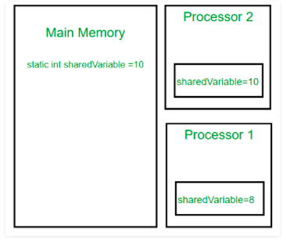

class SharedObj
{
// volatile keyword here makes sure that
// the changes made in one thread are
// immediately reflect in other thread
static volatile int sharedVar = 6;
}

Note that volatile should not be confused with static modifier. static variables are class members that are shared among all objects. There is only one copy of them in main memory.

Atomicity
Atomic operations are those operations that ALWAYS execute together. Either all of them execute together, or none of them executes. If an operation is atomic, then it cannot be partially complete, either it will be complete, or not start at all, but will not be incomplete.
Consider the following example:
1
public class Atomicity {
2
​
3
int i;
4
​
5
public void incrementNumber() {
6
i = 1;
7
}
8
}

In the above example, we are writing value 1 to an int i. This is an atomic operation since this will either happen all together, assigning 1 to i, or it won’t happen at all. This property of an operation, or a set of operations, being atomic is known as atomicity.
Now, consider the following example:
1
public class Atomicity {
2
​
3
int i;
4
​
5
public void incrementNumber() {
6
i = i + 1;
7
}
8
}

At first glance, this might seem like an atomic operation, but it is actually not. This one-liner actually consists of three operations.
- Read operation, where the value of i is read.
- Modify operation, where a new value is being calculated (i + 1).
- Write operation, where the new value is written to the variable i.
Now, since these operations are separate, these set of operations are currently not atomic, since it is possible for them to partially execute. This might be a little hard to understand in a single-threaded environment, but just imagine running this piece of code on multiple threads. If we call this method two times on a single thread, it will result in i being equal to 2. But imagine calling it on two threads. The result should ideally remain the same, but if we call this method on two threads at the same time, then thread A and B will both read the value at the same time and update the value at the same time as well, resulting i to be equal to 1. This is happening because the set of operations here are not atomic. Let’s see how we can make these set of operations atomic.

Atomic Variables
Atomic variables come to the rescue in these types of situations. Atomic variables allow us to perform atomic operations on the variables.
Consider the following example:
1
import java.util.concurrent.atomic.AtomicInteger;
2
​
3
public class Atomicity {
4
​
5
AtomicInteger i;
6
​
7
public void incrementNumber() {
8
i.incrementAndGet();
9
}
10
}

The above example shows how an AtomicInt can be used to update the value atomically. What incrementAndGet() does is atomically increment the value by 1, and then returns the updated value. If the program is now run in a multi-threaded environment, supposing with 2 threads, then the end result will always be i being equal to 2. This is because no matter which thread gets to the incrementAndGet() method first, since it is an atomic operation, the thread will update the value of i to 1, and only then another thread will be able to access or update it, which will make the value of i to 2, thus giving us the correct result.
The most commonly used atomic classes are – AtomicInt, AtomicLong, AtomicBoolean, and AtomicReference. All of these provide atomic operations for the respective classes. AtomicReference can be used for just any type of object.

How to create Immutable class in Java?
Immutable class means that once an object is created, we cannot change its content. In Java, all the wrapper classes (like Integer, Boolean, Byte, Short) and String class is immutable. We can create our own immutable class as well.
Following are the requirements:
- The class must be declared as final (So that child classes can’t be created)
- Data members in the class must be declared as private (So that direct access is not allowed)
- Data members in the class must be declared as final (So that we can’t change the value of it after object creation)
- A parameterized constructor should initialize all the fields performing a deep copy (So that data members can’t be modified with object reference)
- Deep Copy of objects should be performed in the getter methods (To return a copy rather than returning the actual object reference)
- No setters (To not have the option to change the value of the instance variable)

import java.util.HashMap;
import java.util.Map;

// An immutable class
public final class Student {
private final String name;
private final int regNo;
private final Map<String, String> metadata;

public Student(String name, int regNo,
Map<String, String> metadata)
{
this.name = name;
this.regNo = regNo;
Map<String, String> tempMap = new HashMap<>();
for (Map.Entry<String, String> entry :
metadata.entrySet()) {
tempMap.put(entry.getKey(), entry.getValue());
}
this.metadata = tempMap;
}

public String getName() { return name; }

public int getRegNo() { return regNo; }

public Map<String, String> getMetadata()
{
Map<String, String> tempMap = new HashMap<>();
for (Map.Entry<String, String> entry :
this.metadata.entrySet()) {
tempMap.put(entry.getKey(), entry.getValue());
}
return tempMap;
}
}

// Driver class
class Test {
public static void main(String[] args)
{
Map<String, String> map = new HashMap<>();
map.put("1", "first");
map.put("2", "second");
Student s = new Student("ABC", 101, map);
System.out.println(s.getName());
System.out.println(s.getRegNo());
System.out.println(s.getMetadata());

// Uncommenting below line causes error
// s.regNo = 102;

map.put("3", "third");
System.out.println(s.getMetadata()); // Remains unchanged due to deep copy in constructor

s.getMetadata().put("4", "fourth");
System.out.println(s.getMetadata()); // Remains unchanged due to deep copy in getter
}
}

Advantages of Copy Constructors Over Object.clone()
Copy constructors are better than Object.clone() because they:
- Don’t force us to implement any interface or throw an exception, but we can surely do it if it is required.
- Don’t require any type casting.
- Don’t require us to depend on an unknown object creation mechanism.
- Don’t require parent classes to follow any contract or implement anything.
- Allow us to modify final fields.
- Allow us to have complete control over object creation, meaning we can write our initialization logic in it.

Is there Constructor class in Java?
Yes.

What is the purpose of Constructor class?
Java provides a Constructor class which can be used to get the internal information of a constructor in the class. It is found in the java.lang.reflect package.

Q) Does constructor return any value?
Yes, it is the current class instance (You cannot use return type yet it returns a value).
Coupling in Java
In object oriented design, Coupling refers to the degree of direct knowledge that one element has of another. In other words, how often do changes in class A force related changes in class B.
There are two types of coupling:
- Tight coupling : In general, Tight coupling means the two classes often change together. In other words, if A knows more than it should about the way in which B was implemented, then A and B are tightly coupled.
Example : If you want to change the skin, you would also have to change the design of your body as well because the two are joined together – they are tightly coupled. The best example of tight coupling is RMI(Remote Method Invocation).
// Java program to illustrate
// tight coupling concept
class Subject {
Topic t = new Topic();
public void startReading()
{
t.understand();
}
}
class Topic {
public void understand()
{
System.out.println("Tight coupling concept");
}
}
Loose coupling : In simple words, loose coupling means they are mostly independent. If the only knowledge that class A has about class B, is what class B has exposed through its interface, then class A and class B are said to be loosely coupled. In order to over come from the problems of tight coupling between objects, spring framework uses dependency injection mechanism with the help of POJO/POJI model and through dependency injection its possible to achieve loose coupling.
Example : If you change your shirt, then you are not forced to change your body – when you can do that, then you have loose coupling. When you can’t do that, then you have tight coupling. The examples of Loose coupling are Interface, JMS.
// Java program to illustrate
// loose coupling concept
public interface Topic
{
void understand();
}
class Topic1 implements Topic {
public void understand()
{
System.out.println("Got it");
}
} class Topic2 implements Topic {
public void understand()
{
System.out.println("understand");
}
} public class Subject {
public static void main(String[] args)
{
Topic t = new Topic1();
t.understand();
}
}
Cohesion in Java
In object oriented design, cohesion refers all about how a single class is designed. Cohesion is the Object Oriented principle most closely associated with making sure that a class is designed with a single, well-focused purpose.
The more focused a class is, the cohesiveness of that class is more. The advantages of high cohesion is that such classes are much easier to maintain (and less frequently changed) than classes with low cohesion. Another benefit of high cohesion is that classes with a well-focused purpose tend to be more reusable than other classes.
Example : Suppose we have a class that multiply two numbers, but the same class creates a pop up window displaying the result. This is the example of low cohesive class because the window and the multiplication operation don’t have much in common.
To make it high cohesive, we would have to create a class Display and a class Multiply. The Display will call Multiply’s method to get the result and display it. This way to develop a high cohesive solution.
Lets understand the structure of high cohesive program :
// Java program to illustrate
// high cohesive behavior
class Multiply {
int a = 5;
int b = 5;
public int mul(int a, int b)
{
this.a = a;
this.b = b;
return a * b;
}
}

class Display {
public static void main(String[] args)
{
Multiply m = new Multiply();
System.out.println(m.mul(5, 5));
}
}
Output:
25
// Java program to illustrate
// high cohesive behavior
class Name {
String name;
public String getName(String name)
{
this.name = name;
return name;
}
}

class Age {
int age;
public int getAge(int age)
{
this.age = age;
return age;
}
}

class Number {
int mobileno;
public int getNumber(int mobileno)
{
this.mobileno = mobileno;
return mobileno;
}
}

class Display {
public static void main(String[] args)
{
Name n = new Name();
System.out.println(n.getName("Geeksforgeeks"));
Age a = new Age();
System.out.println(a.getAge(10));
Number no = new Number();
System.out.println(no.getNumber(1234567891));
}
}
Output:

Geeksforgeeks
10
1234567891
Pictorial view of high cohesion and low cohesion:
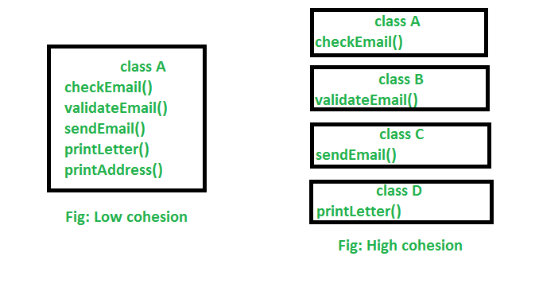
Explanation : In the above image, we can see that in low cohesion only one class is responsible to execute lots of job which are not in common which reduces the chance of re-usability and maintenance. But in high cohesion there is a separate class for all the jobs to execute a specific job, which result better usability and maintenance.
Difference between high cohesion and low cohesion:
- High cohesion is when you have a class that does a well defined job. Low cohesion is when a class does a lot of jobs that don’t have much in common.
- High cohesion gives us better maintaining facility and Low cohesion results in monolithic classes that are difficult to maintain, understand and reduces re-usability

Types Of Relationship
Based on reusing the data members from one class to another class in JAVA we have three types of relationships. They are is-a relationship, has-a relationship and uses-a relationship.
- Is-a relationship is one in which data members of one class is obtained into another class through the concept of inheritance.
- Has-a relationship is one in which an object of one class is created as a data member in another class.
- Uses-a relationship is one in which a method of one class is using an object of another class.
Inheritance is the technique which allows us to inherit the data members and methods from base class to derived class.
- Base class is one which always gives its features to derived classes.
- Derived class is one which always takes features from base class.
A Derived class is one which contains some of features of its own plus some of the data members from base class

Syntax for Inheriting the features from base class to derived class:
class <clsname-2> extends <clsname-1>
{
Variable declaration;
Method definition;
};
Here, clsname-1 and clsname-2 represents derived class and base class respectively.
Extends is a keyword which is used for inheriting the data members and methods from base class to the derived class and it also improves functionality of derived class.
Note:
- Final classes cannot be inherited.
- If the base class contains private data members then that type of data members will not be inherited into derived class.
Whenever we develop any inheritance application, it is always recommended to create an object of bottom most derived class. Since, bottom most derived class contains all the features from its super classes.
- One class can extend only one class at a time. Since, JAVA does not support multiple inheritance.
Whenever we inherit the base class members into derived class, when we creates an object of derived class, JVM always creates the memory space for base class members first and later memory space will be created for derived class members.
For example:
class c1;
{
int a;
void f1()
{
.......;
}
};

class c2 extends c1
{
int b;
void f2()
{
.......;
}
};
Note:
- Whatever the data members are coming from base class to the derived class, the base class members are logically declared in derived class, the base class methods are logically defined in derived class.
- Private data members and private methods of the base class will not be inherited at all.
Write a JAVA program computes sum of two numbers using inheritance?
Answer:
class Bc
{
int a;
};

class Dc extends Bc
{
int b;
void set (int x, int y)
{
a=x;
b=y;
}
void sum ()
{
System.out.println ("SUM = "+(a+b));
}
};

class InDemo
{
public static void main (String k [])
{
int n1=Integer.parseInt (k [0]);
int n2=Integer.parseInt (k [1]);
Dc do1=new Dc ();
do1.set (n1, n2);
do1.sum ();
}
};
For every class in JAVA we have a super class called object class. The purpose of object class is that it provides garbage collector for collecting unreferenced memory locations from the derived classes.

Design Pattern :

What are the SOLID principles in Java?
SOLID principles are object-oriented design concepts relevant to software development. SOLID is an acronym for five other class-design principles: Single Responsibility Principle, Open-Closed Principle, Liskov Substitution Principle, Interface Segregation Principle, and Dependency Inversion Principle.
Principle | Description
Single Responsibility Principle | Each class should be responsible for a single part or functionality of the system.
Open-Closed Principle | Software components should be open for extension, but not for modification.
Liskov Substitution Principle | Objects of a superclass should be replaceable with objects of its subclasses without breaking the system.
Interface Segregation Principle | No client should be forced to depend on methods that it does not use.
Dependency Inversion Principle | High-level modules should not depend on low-level modules, both should depend on abstractions.
SOLID is a structured design approach that ensures your software is modular and easy to maintain, understand, debug, and refactor. Following SOLID also helps save time and effort in both development and maintenance. SOLID prevents your code from becoming rigid and fragile, which helps you build long-lasting software.

Examples

1. Single responsibility principle
Every class in Java should have a single job to do. To be precise, there should only be one reason to change a class. Here’s an example of a Java class that does not follow the single responsibility principle (SRP):
public class Vehicle {
public void printDetails() {}
public double calculateValue() {}
public void addVehicleToDB() {}
}
The Vehicle class has three separate responsibilities: reporting, calculation, and database. By applying SRP, we can separate the above class into three classes with separate responsibilities.

2. Open-closed principle
Software entities (e.g., classes, modules, functions) should be open for an extension, but closed for modification.
Consider the below method of the class VehicleCalculations:
public class VehicleCalculations {
public double calculateValue(Vehicle v) {
if (v instanceof Car) {
return v.getValue() * 0.8;
if (v instanceof Bike) {
return v.getValue() * 0.5;
}
}
Suppose we now want to add another subclass called Truck. We would have to modify the above class by adding another if statement, which goes against the Open-Closed Principle.
A better approach would be for the subclasses Car and Truck to override the calculateValue method:
public class Vehicle {
public double calculateValue() {...}
}
public class Car extends Vehicle {
public double calculateValue() {
return this.getValue() * 0.8;
}
public class Truck extends Vehicle{
public double calculateValue() {
return this.getValue() * 0.9;
}
Adding another Vehicle type is as simple as making another subclass and extending from the Vehicle class.

3. Liskov substitution principle
The Liskov Substitution Principle (LSP) applies to inheritance hierarchies such that derived classes must be completely substitutable for their base classes.
Consider a typical example of a Square derived class and Rectangle base class:
public class Rectangle {
private double height;
private double width;
public void setHeight(double h) { height = h; }
public void setWidht(double w) { width = w; }
...
}
public class Square extends Rectangle {
public void setHeight(double h) {
super.setHeight(h);
super.setWidth(w);
}
public void setWidth(double h) {
super.setHeight(h);
super.setWidth(w);
}
}
The above classes do not obey LSP because you cannot replace the Rectangle base class with its derived class Square. The Square class has extra constraints, i.e., the height and width must be the same. Therefore, substituting Rectangle with Square class may result in unexpected behavior.

4. Interface segregation principle
The Interface Segregation Principle (ISP) states that clients should not be forced to depend upon interface members they do not use. In other words, do not force any client to implement an interface that is irrelevant to them.
Suppose there’s an interface for vehicle and a Bike class:
public interface Vehicle {
public void drive();
public void stop();
public void refuel();
public void openDoors();
}
public class Bike implements Vehicle {
// Can be implemented
public void drive() {...}
public void stop() {...}
public void refuel() {...}
// Can not be implemented
public void openDoors() {...}
}
As you can see, it does not make sense for a Bike class to implement the openDoors() method as a bike does not have any doors! To fix this, ISP proposes that the interfaces be broken down into multiple, small cohesive interfaces so that no class is forced to implement any interface, and therefore methods, that it does not need.

5. Dependency inversion principle
The Dependency Inversion Principle (DIP) states that we should depend on abstractions (interfaces and abstract classes) instead of concrete implementations (classes). The abstractions should not depend on details; instead, the details should depend on abstractions.
Consider the example below. We have a Car class that depends on the concrete Engine class; therefore, it is not obeying DIP.
public class Car {
private Engine engine;
public Car(Engine e) {
engine = e;
}
public void start() {
engine.start();
}
}
public class Engine {
public void start() {...}
}
The code will work, for now, but what if we wanted to add another engine type, let’s say a diesel engine? This will require refactoring the Car class.
However, we can solve this by introducing a layer of abstraction. Instead of Car depending directly on Engine, let’s add an interface:
public interface EngineInterface {
public void start();
}
Now we can connect any type of Engine that implements the Engine interface to the Car class:
public class Car {
private EngineInterface engine;
public Car(EngineInterface e) {
engine = e;
}
public void start() {
engine.start();
}
}
public class PetrolEngine implements EngineInterface {
public void start() {...}
}
public class DieselEngine implements EngineInterface {
public void start() {...}
}

Performance Analysis of ArrayList and LinkedList in Java
ArrayListuses the Array data structure, and LinkedList uses the DoublyLinkedList data structure. Here, we are going to discuss how the underlying data structure affects the performance of insert, search, and delete operation on ArrayList and LinkedList.
Operation | LinkedList time complexity | ArrayList time complexity | Preferred
Insert at last index | O(1) | O(1)  (If array copy operation is Considered then O(N)) | LinkedList
Insert at given index | O(N) | O(N) | LinkedList
Search by value | O(N) | O(N) | ArrayList
Get by index | O(N) | O(1) | ArrayList
Remove by value | O(N) | O(N) | LinkedList
Remove by index | O(N) | O(N) | LinkedList

Vector time complexity in Java
Good for
Retrieving elements from a specific position – O (1).
Adding and removing elements from the end. Constant time complexity – O(1).
Note : Adding and removing elements from any other position is expensive — Lenear: O(n-i), where n is the number of elements and i is the index of the element added or removed. These operations are more expensive because you have to shift all elements at index i and higher over by one element.
Uses:

Below are the Big O performance of common functions of different Java Collections.

List | Add | Remove | Get | Contains | Next | Data Structure

---------------------|------|--------|------|----------|------|---------------

ArrayList | O(1) | O(n) | O(1) | O(n) | O(1) | Array

LinkedList | O(1) | O(1) | O(n) | O(n) | O(1) | Linked List

CopyOnWriteArrayList | O(n) | O(n) | O(1) | O(n) | O(1) | Array

Set | Add | Remove | Contains | Next | Size | Data Structure

----------------------|----------|----------|----------|----------|------|-------------------------

HashSet | O(1) | O(1) | O(1) | O(h/n) | O(1) | Hash Table

LinkedHashSet | O(1) | O(1) | O(1) | O(1) | O(1) | Hash Table + Linked List

EnumSet | O(1) | O(1) | O(1) | O(1) | O(1) | Bit Vector

TreeSet | O(log n) | O(log n) | O(log n) | O(log n) | O(1) | Red-black tree

CopyOnWriteArraySet | O(n) | O(n) | O(n) | O(1) | O(1) | Array

ConcurrentSkipListSet | O(log n) | O(log n) | O(log n) | O(1) | O(n) | Skip List

Queue | Offer | Peak | Poll | Remove | Size | Data Structure

------------------------|----------|------|----------|--------|------|---------------

PriorityQueue | O(log n) | O(1) | O(log n) | O(n) | O(1) | Priority Heap

LinkedList | O(1) | O(1) | O(1) | O(1) | O(1) | Array

ArrayDequeue | O(1) | O(1) | O(1) | O(n) | O(1) | Linked List

ConcurrentLinkedQueue | O(1) | O(1) | O(1) | O(n) | O(n) | Linked List

ArrayBlockingQueue | O(1) | O(1) | O(1) | O(n) | O(1) | Array

PriorirityBlockingQueue | O(log n) | O(1) | O(log n) | O(n) | O(1) | Priority Heap

SynchronousQueue | O(1) | O(1) | O(1) | O(n) | O(1) | None!

DelayQueue | O(log n) | O(1) | O(log n) | O(n) | O(1) | Priority Heap

LinkedBlockingQueue | O(1) | O(1) | O(1) | O(n) | O(1) | Linked List

Map | Get | ContainsKey | Next | Data Structure

----------------------|----------|-------------|----------|-------------------------

HashMap | O(1) | O(1) | O(h / n) | Hash Table

LinkedHashMap | O(1) | O(1) | O(1) | Hash Table + Linked List

IdentityHashMap | O(1) | O(1) | O(h / n) | Array

WeakHashMap | O(1) | O(1) | O(h / n) | Hash Table

EnumMap | O(1) | O(1) | O(1) | Array

TreeMap | O(log n) | O(log n) | O(log n) | Red-black tree

ConcurrentHashMap | O(1) | O(1) | O(h / n) | Hash Tables

ConcurrentSkipListMap | O(log n) | O(log n) | O(1) | Skip List

Creational design patterns
Creational design patterns are concerned with the way of creating objects. These design patterns are used when a decision must be made at the time of instantiation of a class (i.e. creating an object of a class).
But everyone knows an object is created by using new keyword in java. For example:
- StudentRecord s1=new StudentRecord();
Hard-Coded code is not the good programming approach. Here, we are creating the instance by using the new keyword. Sometimes, the nature of the object must be changed according to the nature of the program. In such cases, we must get the help of creational design patterns to provide more general and flexible approach.

Singleton design pattern in Java
Singleton Pattern says that just"define a class that has only one instance and provides a global point of access to it".
In other words, a class must ensure that only single instance should be created and single object can be used by all other classes.

Factory Method Pattern
A Factory Pattern or Factory Method Pattern says that just define an interface or abstract class for creating an object but let the subclasses decide which class to instantiate. In other words, subclasses are responsible to create the instance of the class.
The Factory Method Pattern is also known as Virtual Constructor.

Advantage of Factory Design Pattern
- Factory Method Pattern allows the sub-classes to choose the type of objects to create.
- It promotes the loose-coupling by eliminating the need to bind application-specific classes into the code. That means the code interacts solely with the resultant interface or abstract class, so that it will work with any classes that implement that interface or that extends that abstract class.

Usage of Factory Design Pattern
- When a class doesn't know what sub-classes will be required to create
- When a class wants that its sub-classes specify the objects to be created.
- When the parent classes choose the creation of objects to its sub-classes.
- We are going to create a Plan abstract class and concrete classes that extends the Plan abstract class. A factory class GetPlanFactory is defined as a next step.
- GenerateBill class will use GetPlanFactory to get a Plan object. It will pass information (DOMESTICPLAN / COMMERCIALPLAN / INSTITUTIONALPLAN) to GetPalnFactory to get the type of object it needs.
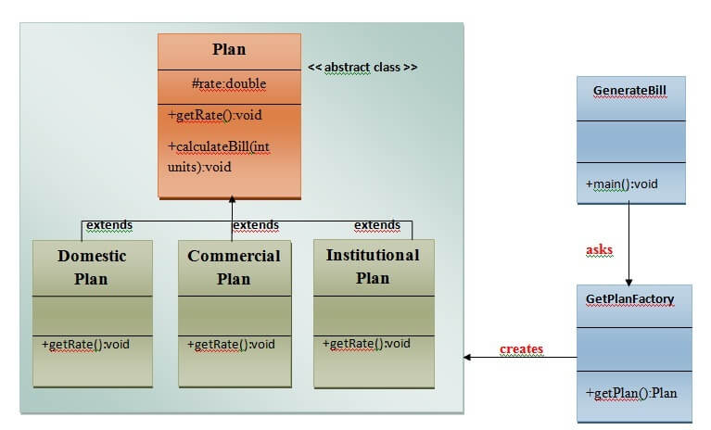

Calculate Electricity Bill : A Real World Example of Factory Method
Step 1: Create a Plan abstract class.
- import java.io.*;
- abstract class Plan{
- protected double rate;
- abstract void getRate();

- public void calculateBill(int units){
- System.out.println(units*rate);
- }
- }//end of Plan class.
Step 2: Create the concrete classes that extends Plan abstract class.
- class DomesticPlan extends Plan{
- //@override
- public void getRate(){
- rate=3.50;
- }
- }//end of DomesticPlan class.
- class CommercialPlan extends Plan{
- //@override
- public void getRate(){
- rate=7.50;
- }
- /end of CommercialPlan class.
- class InstitutionalPlan extends Plan{
- //@override
- public void getRate(){
- rate=5.50;
- }
- /end of InstitutionalPlan class.
Step 3: Create a GetPlanFactory to generate object of concrete classes based on given information..
- class GetPlanFactory{

- //use getPlan method to get object of type Plan
- public Plan getPlan(String planType){
- if(planType == null){
- return null;
- }
- if(planType.equalsIgnoreCase("DOMESTICPLAN")) {
- return new DomesticPlan();
- }
- else if(planType.equalsIgnoreCase("COMMERCIALPLAN")){
- return new CommercialPlan();
- }
- else if(planType.equalsIgnoreCase("INSTITUTIONALPLAN")) {
- return new InstitutionalPlan();
- }
- return null;
- }
- }//end of GetPlanFactory class.
Step 4: Generate Bill by using the GetPlanFactory to get the object of concrete classes by passing an information such as type of plan DOMESTICPLAN or COMMERCIALPLAN or INSTITUTIONALPLAN.
- import java.io.*;
- class GenerateBill{
- public static void main(String args[])throws IOException{
- GetPlanFactory planFactory = new GetPlanFactory();

- System.out.print("Enter the name of plan for which the bill will be generated: ");
- BufferedReader br=new BufferedReader(new InputStreamReader(System.in));

- String planName=br.readLine();
- System.out.print("Enter the number of units for bill will be calculated: ");
- int units=Integer.parseInt(br.readLine());

- Plan p = planFactory.getPlan(planName);
- //call getRate() method and calculateBill()method of DomesticPaln.

- System.out.print("Bill amount for "+planName+" of "+units+" units is: ");
- p.getRate();
- p.calculateBill(units);
- }
- }//end of GenerateBill class.

https://www.javatpoint.com/factory-method-design-pattern

Abstract Factory Pattern
Abstract Factory Pattern says that just define an interface or abstract class for creating families of related (or dependent) objects but without specifying their concrete sub-classes.That means Abstract Factory lets a class returns a factory of classes. So, this is the reason that Abstract Factory Pattern is one level higher than the Factory Pattern.
An Abstract Factory Pattern is also known as Kit.

Advantage of Abstract Factory Pattern
- Abstract Factory Pattern isolates the client code from concrete (implementation) classes.
- It eases the exchanging of object families.
- It promotes consistency among objects.

Usage of Abstract Factory Pattern
- When the system needs to be independent of how its object are created, composed, and represented.
- When the family of related objects has to be used together, then this constraint needs to be enforced.
- When you want to provide a library of objects that does not show implementations and only reveals interfaces.
- When the system needs to be configured with one of a multiple family of objects.

UML for Abstract Factory Pattern
- We are going to create a Bank interface and a Loan abstract class as well as their sub-classes.
- Then we will create AbstractFactory class as next step.
- Then after we will create concrete classes, BankFactory, and LoanFactory that will extends AbstractFactory class
- After that, AbstractFactoryPatternExample class uses the FactoryCreator to get an object of AbstractFactory class.
- See the diagram carefully which is given below:
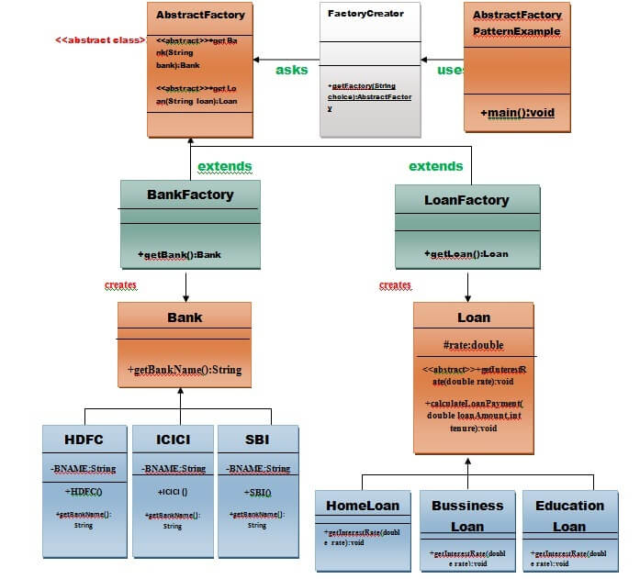

Example of Abstract Factory Pattern
Here, we are calculating the loan payment for different banks like HDFC, ICICI, SBI etc.
Step 1: Create a Bank interface
- import java.io.*;
- interface Bank{
- String getBankName();
- }
Step 2: Create concrete classes that implement the Bank interface.
- class HDFC implements Bank{
- private final String BNAME;
- public HDFC(){
- BNAME="HDFC BANK";
- }
- public String getBankName() {
- return BNAME;
- }
- }
- class ICICI implements Bank{
- private final String BNAME;
- ICICI(){
- BNAME="ICICI BANK";
- }
- public String getBankName() {
- return BNAME;
- }
- }
- class SBI implements Bank{
- private final String BNAME;
- public SBI(){
- BNAME="SBI BANK";
- }
- public String getBankName(){
- return BNAME;
- }
- }
Step 3: Create the Loan abstract class.
- abstract class Loan{
- protected double rate;
- abstract void getInterestRate(double rate);
- public void calculateLoanPayment(double loanamount, int years)
- {
- /*
- to calculate the monthly loan payment i.e. EMI

- rate=annual interest rate/12*100;
- n=number of monthly installments;
- 1year=12 months.
- so, n=years*12;

- */

- double EMI;
- int n;

- n=years*12;
- rate=rate/1200;
- EMI=((rate*Math.pow((1+rate),n))/((Math.pow((1+rate),n))-1))*loanamount;

- System.out.println("your monthly EMI is "+ EMI +" for the amount"+loanamount+" you have borrowed");
- }
- }// end of the Loan abstract class.
Step 4: Create concrete classes that extend the Loan abstract class..
- class HomeLoan extends Loan{
- public void getInterestRate(double r){
- rate=r;
- }
- }//End of the HomeLoan class.
- class BussinessLoan extends Loan{
- public void getInterestRate(double r){
- rate=r;
- }

- }//End of the BusssinessLoan class.
- class EducationLoan extends Loan{
- public void getInterestRate(double r){
- rate=r;
- }
- }//End of the EducationLoan class.
Step 5: Create an abstract class (i.e AbstractFactory) to get the factories for Bank and Loan Objects.
- abstract class AbstractFactory{
- public abstract Bank getBank(String bank);
- public abstract Loan getLoan(String loan);
- }
Step 6: Create the factory classes that inherit AbstractFactory class to generate the object of concrete class based on given information.
- class BankFactory extends AbstractFactory{
- public Bank getBank(String bank){
- if(bank == null){
- return null;
- }
- if(bank.equalsIgnoreCase("HDFC")){
- return new HDFC();
- } else if(bank.equalsIgnoreCase("ICICI")){
- return new ICICI();
- } else if(bank.equalsIgnoreCase("SBI")){
- return new SBI();
- }
- return null;
- }
- public Loan getLoan(String loan) {
- return null;
- }
- }//End of the BankFactory class.
- class LoanFactory extends AbstractFactory{
- public Bank getBank(String bank){
- return null;
- }

- public Loan getLoan(String loan){
- if(loan == null){
- return null;
- }
- if(loan.equalsIgnoreCase("Home")){
- return new HomeLoan();
- } else if(loan.equalsIgnoreCase("Business")){
- return new BussinessLoan();
- } else if(loan.equalsIgnoreCase("Education")){
- return new EducationLoan();
- }
- return null;
- }

- }
Step 7: Create a FactoryCreator class to get the factories by passing an information such as Bank or Loan.

- class FactoryCreator {
- public static AbstractFactory getFactory(String choice){
- if(choice.equalsIgnoreCase("Bank")){
- return new BankFactory();
- } else if(choice.equalsIgnoreCase("Loan")){
- return new LoanFactory();
- }
- return null;
- }
- }//End of the FactoryCreator.
Step 8: Use the FactoryCreator to get AbstractFactory in order to get factories of concrete classes by passing an information such as type.
- import java.io.*;
- class AbstractFactoryPatternExample {
- public static void main(String args[])throws IOException {

- BufferedReader br=new BufferedReader(new InputStreamReader(System.in));

- System.out.print("Enter the name of Bank from where you want to take loan amount: ");
- String bankName=br.readLine();

- System.out.print("\n");
- System.out.print("Enter the type of loan e.g. home loan or business loan or education loan : ");

- String loanName=br.readLine();
- AbstractFactory bankFactory = FactoryCreator.getFactory("Bank");
- Bank b=bankFactory.getBank(bankName);

- System.out.print("\n");
- System.out.print("Enter the interest rate for "+b.getBankName()+ ": ");

- double rate=Double.parseDouble(br.readLine());
- System.out.print("\n");
- System.out.print("Enter the loan amount you want to take: ");

- double loanAmount=Double.parseDouble(br.readLine());
- System.out.print("\n");
- System.out.print("Enter the number of years to pay your entire loan amount: ");
- int years=Integer.parseInt(br.readLine());

- System.out.print("\n");
- System.out.println("you are taking the loan from "+ b.getBankName());

- AbstractFactory loanFactory = FactoryCreator.getFactory("Loan");
- Loan l=loanFactory.getLoan(loanName);
- l.getInterestRate(rate);
- l.calculateLoanPayment(loanAmount,years);
- }
- }//End of the AbstractFactoryPatternExample

Builder Design Pattern
Builder Pattern says that "construct a complex object from simple objects using step-by-step approach"
It is mostly used when object can't be created in single step like in the de-serialization of a complex object.

Advantage of Builder Design Pattern
The main advantages of Builder Pattern are as follows:
- It provides clear separation between the construction and representation of an object.
- It provides better control over construction process.
- It supports to change the internal representation of objects.

UML for Builder Pattern Example
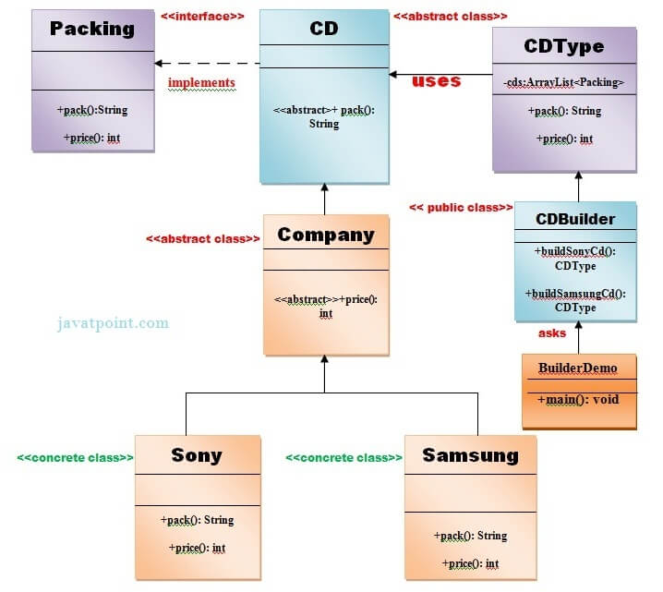

Example of Builder Design Pattern
To create simple example of builder design pattern, you need to follow 6 following steps.
- Create Packing interface
- Create 2 abstract classes CD and Company
- Create 2 implementation classes of Company: Sony and Samsung
- Create the CDType class
- Create the CDBuilder class
- Create the BuilderDemo class

Create Packing interface
File: Packing.java
- public interface Packing {
- public String pack();
- public int price();
- }

2) Create 2 abstract classes CD and Company
Create an abstract class CD which will implement Packing interface.
File: CD.java
- public abstract class CD implements Packing{
- public abstract String pack();
- }
File: Company.java
- public abstract class Company extends CD{
- public abstract int price();
- }

3) Create 2 implementation classes of Company: Sony and Samsung
File: Sony.java
- public class Sony extends Company{
- @Override
- public int price(){
- return 20;
- }
- @Override
- public String pack(){
- return "Sony CD";
- }
- }//End of the Sony class.
File: Samsung.java
- public class Samsung extends Company {
- @Override
- public int price(){
- return 15;
- }
- @Override
- public String pack(){
- return "Samsung CD";
- }
- }//End of the Samsung class.

4) Create the CDType class
File: CDType.java
- import java.util.ArrayList;
- import java.util.List;
- public class CDType {
- private List<Packing> items=new ArrayList<Packing>();
- public void addItem(Packing packs) {
- items.add(packs);
- }
- public void getCost(){
- for (Packing packs : items) {
- packs.price();
- }
- }
- public void showItems(){
- for (Packing packing : items){
- System.out.print("CD name : "+packing.pack());
- System.out.println(", Price : "+packing.price());
- }
- }
- }//End of the CDType class.

5) Create the CDBuilder class
ADVERTISEMENT
File: CDBuilder.java
- public class CDBuilder {
- public CDType buildSonyCD(){
- CDType cds=new CDType();
- cds.addItem(new Sony());
- return cds;
- }
- public CDType buildSamsungCD(){
- CDType cds=new CDType();
- cds.addItem(new Samsung());
- return cds;
- }
- }// End of the CDBuilder class.

6) Create the BuilderDemo class
File: BuilderDemo.java
- public class BuilderDemo{
- public static void main(String args[]){
- CDBuilder cdBuilder=new CDBuilder();
- CDType cdType1=cdBuilder.buildSonyCD();
- cdType1.showItems();

- CDType cdType2=cdBuilder.buildSamsungCD();
- cdType2.showItems();
- }
- }

Prototype Design Pattern
Prototype Pattern says that cloning of an existing object instead of creating new one and can also be customized as per the requirement.
This pattern should be followed, if the cost of creating a new object is expensive and resource intensive.

Advantage of Prototype Pattern
The main advantages of prototype pattern are as follows:
- It reduces the need of sub-classing.
- It hides complexities of creating objects.
- The clients can get new objects without knowing which type of object it will be.
- It lets you add or remove objects at runtime.

Usage of Prototype Pattern
- When the classes are instantiated at runtime.
- When the cost of creating an object is expensive or complicated.
- When you want to keep the number of classes in an application minimum.
- When the client application needs to be unaware of object creation and representation.

UML for Prototype Pattern
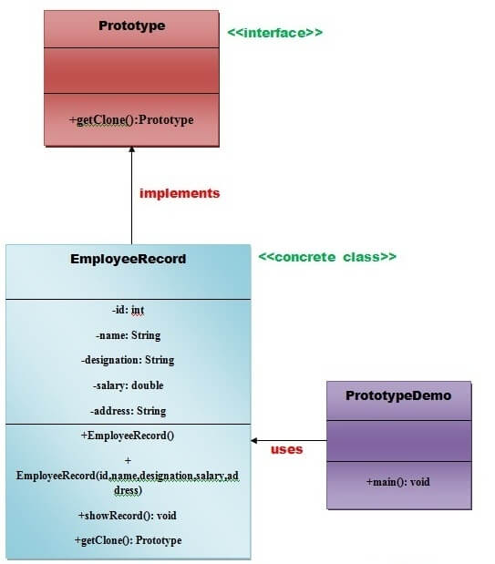
ADVERTISEMENT
- We are going to create an interface Prototype that contains a method getClone() of Prototype type.
- Then, we create a concrete class EmployeeRecord which implements Prototype interface that does the cloning of EmployeeRecord object.
- PrototypeDemo class will uses this concrete class EmployeeRecord.

Example of Prototype Design Pattern
Let's see the example of prototype design pattern.
File: Prototype.java
- interface Prototype {

- public Prototype getClone();

- }//End of Prototype interface.
File: EmployeeRecord.java
- class EmployeeRecord implements Prototype{

- private int id;
- private String name, designation;
- private double salary;
- private String address;

- public EmployeeRecord(){
- System.out.println(" Employee Records of Oracle Corporation ");
- System.out.println("---------------------------------------------");
- System.out.println("Eid"+"\t"+"Ename"+"\t"+"Edesignation"+"\t"+"Esalary"+"\t\t"+"Eaddress");

- }

- public EmployeeRecord(int id, String name, String designation, double salary, String address) {

- this();
- this.id = id;
- this.name = name;
- this.designation = designation;
- this.salary = salary;
- this.address = address;
- }

- public void showRecord(){

- System.out.println(id+"\t"+name+"\t"+designation+"\t"+salary+"\t"+address);
- }

- @Override
- public Prototype getClone() {

- return new EmployeeRecord(id,name,designation,salary,address);
- }
- }//End of EmployeeRecord class.
File: PrototypeDemo.java
- import java.io.BufferedReader;
- import java.io.IOException;
- import java.io.InputStreamReader;

- class PrototypeDemo{
- public static void main(String[] args) throws IOException {

- BufferedReader br =new BufferedReader(new InputStreamReader(System.in));
- System.out.print("Enter Employee Id: ");
- int eid=Integer.parseInt(br.readLine());
- System.out.print("\n");

- System.out.print("Enter Employee Name: ");
- String ename=br.readLine();
- System.out.print("\n");

- System.out.print("Enter Employee Designation: ");
- String edesignation=br.readLine();
- System.out.print("\n");

- System.out.print("Enter Employee Address: ");
- String eaddress=br.readLine();
- System.out.print("\n");

- System.out.print("Enter Employee Salary: ");
- double esalary= Double.parseDouble(br.readLine());
- System.out.print("\n");

- EmployeeRecord e1=new EmployeeRecord(eid,ename,edesignation,esalary,eaddress);

- e1.showRecord();
- System.out.println("\n");
- EmployeeRecord e2=(EmployeeRecord) e1.getClone();
- e2.showRecord();
- }
- }//End of the ProtoypeDemo class.

Singleton design pattern in Java
Singleton Pattern says that just"define a class that has only one instance and provides a global point of access to it".
In other words, a class must ensure that only single instance should be created and single object can be used by all other classes.
There are two forms of singleton design pattern
- Early Instantiation: creation of instance at load time.
- Lazy Instantiation: creation of instance when required.

Structural design patterns
Structural design patterns are concerned with how classes and objects can be composed, to form larger structures.
The structural design patterns simplifies the structure by identifying the relationships.
These patterns focus on, how the classes inherit from each other and how they are composed from other classes.

Types of structural design patterns
There are following 7 types of structural design patterns.
- Adapter Pattern
Adapting an interface into another according to client expectation.
- Bridge Pattern
Separating abstraction (interface) from implementation.
- Composite Pattern
Allowing clients to operate on hierarchy of objects.
- Decorator Pattern
Adding functionality to an object dynamically.
- Facade Pattern
Providing an interface to a set of interfaces.
- Flyweight Pattern
Reusing an object by sharing it.
- proxy Pattern
Representing another object.

Adapter Pattern
An Adapter Pattern says that just "converts the interface of a class into another interface that a client wants".
In other words, to provide the interface according to client requirement while using the services of a class with a different interface.
The Adapter Pattern is also known as Wrapper.

Advantage of Adapter Pattern
- It allows two or more previously incompatible objects to interact.
- It allows reusability of existing functionality.
- Example:
- Suppose you have a Bird class with fly() , and makeSound()methods. And also a ToyDuck class with squeak() method. Let’s assume that you are short on ToyDuck objects and you would like to use Bird objects in their place. Birds have some similar functionality but implement a different interface, so we can’t use them directly. So we will use adapter pattern. Here our client would be ToyDuck and adaptee would be Bird.
- Below is Java implementation of it.
// Java implementation of Adapter pattern

interface Bird
{
// birds implement Bird interface that allows
// them to fly and make sounds adaptee interface
public void fly();
public void makeSound();
}

class Sparrow implements Bird
{
// a concrete implementation of bird
public void fly()
{
System.out.println("Flying");
}
public void makeSound()
{
System.out.println("Chirp Chirp");
}
}

interface ToyDuck
{
// target interface
// toyducks dont fly they just make
// squeaking sound
public void squeak();
}

class PlasticToyDuck implements ToyDuck
{
public void squeak()
{
System.out.println("Squeak");
}
}

class BirdAdapter implements ToyDuck
{
// You need to implement the interface your
// client expects to use.
Bird bird;
public BirdAdapter(Bird bird)
{
// we need reference to the object we
// are adapting
this.bird = bird;
}

public void squeak()
{
// translate the methods appropriately
bird.makeSound();
}
}

class Main
{
public static void main(String args[])
{
Sparrow sparrow = new Sparrow();
ToyDuck toyDuck = new PlasticToyDuck();

// Wrap a bird in a birdAdapter so that it
// behaves like toy duck
ToyDuck birdAdapter = new BirdAdapter(sparrow);

System.out.println("Sparrow...");
sparrow.fly();
sparrow.makeSound();

System.out.println("ToyDuck...");
toyDuck.squeak();

// toy duck behaving like a bird
System.out.println("BirdAdapter...");
birdAdapter.squeak();
}
}
- Output:
- Sparrow...
- Flying
- Chirp Chirp
- ToyDuck...
- Squeak
- BirdAdapter...
- Chirp Chirp
- Explanation :
Suppose we have a bird that can makeSound(), and we have a plastic toy duck that can squeak(). Now suppose our client changes the requirement and he wants the toyDuck to makeSound than ?
Simple solution is that we will just change the implementation class to the new adapter class and tell the client to pass the instance of the bird(which wants to squeak()) to that class.
Before : ToyDuck toyDuck = new PlasticToyDuck();
After : ToyDuck toyDuck = new BirdAdapter(sparrow);
You can see that by changing just one line the toyDuck can now do Chirp Chirp !!

Bridge Pattern
A Bridge Pattern says that just "decouple the functional abstraction from the implementation so that the two can vary independently".
The Bridge Pattern is also known as Handle or Body.

Advantage of Bridge Pattern
- It enables the separation of implementation from the interface.
- It improves the extensibility.
- It allows the hiding of implementation details from the client.

Usage of Bridge Pattern
- When you don't want a permanent binding between the functional abstraction and its implementation.
- When both the functional abstraction and its implementation need to extended using sub-classes.
- It is mostly used in those places where changes are made in the implementation does not affect the clients.

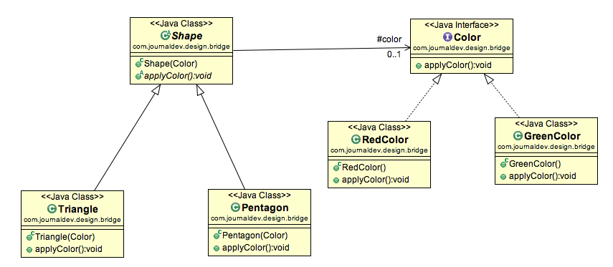

Bridge Design Pattern in Java Example
If we look into bridge design pattern with example, it will be easy to understand. Lets say we have an interface hierarchy in both interfaces and implementations like below image.
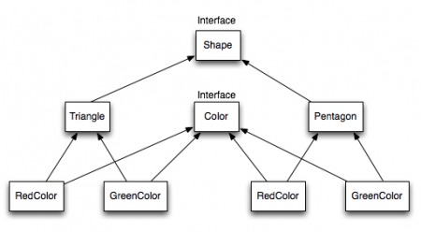
Now we will use bridge design pattern to decouple the interfaces from implementation. UML diagram for the classes and interfaces after applying bridge pattern will look like below image.
Notice the bridge between Shape and Color interfaces and use of composition in implementing the bridge pattern.
Here is the java code for Shape and Color interfaces.

package com.journaldev.design.bridge;

public interface Color {

public void applyColor();
}
Shape.java

package com.journaldev.design.bridge;

public abstract class Shape {
//Composition - implementor
protected Color color;

//constructor with implementor as input argument
public Shape(Color c){
this.color=c;
}

abstract public void applyColor();
}
We have Triangle and Pentagon implementation classes as below.
Triangle.java

package com.journaldev.design.bridge;

public class Triangle extends Shape{

public Triangle(Color c) {
super(c);
}

@Override
public void applyColor() {
System.out.print("Triangle filled with color ");
color.applyColor();
}

}
Pentagon.java

package com.journaldev.design.bridge;

public class Pentagon extends Shape{

public Pentagon(Color c) {
super(c);
}

@Override
public void applyColor() {
System.out.print("Pentagon filled with color ");
color.applyColor();
}

}
Here are the implementation classes for RedColor and GreenColor.
RedColor.java

package com.journaldev.design.bridge;

public class RedColor implements Color{

public void applyColor(){
System.out.println("red.");
}
}
GreenColor.java

package com.journaldev.design.bridge;

public class GreenColor implements Color{

public void applyColor(){
System.out.println("green.");
}
}
Lets test our bridge pattern implementation with a test program.
BridgePatternTest.java

package com.journaldev.design.test;

import com.journaldev.design.bridge.GreenColor;
import com.journaldev.design.bridge.Pentagon;
import com.journaldev.design.bridge.RedColor;
import com.journaldev.design.bridge.Shape;
import com.journaldev.design.bridge.Triangle;

public class BridgePatternTest {

public static void main(String[] args) {
Shape tri = new Triangle(new RedColor());
tri.applyColor();

Shape pent = new Pentagon(new GreenColor());
pent.applyColor();
}

}
Output of above bridge pattern example program is:

Triangle filled with color red.
Pentagon filled with color green.

Decorator Pattern
A Decorator Pattern says that just "attach a flexible additional responsibilities to an object dynamically".
In other words, The Decorator Pattern uses composition instead of inheritance to extend the functionality of an object at runtime.
The Decorator Pattern is also known as Wrapper.

Advantage of Decorator Pattern
- It provides greater flexibility than static inheritance.
- It enhances the extensibility of the object, because changes are made by coding new classes.
- It simplifies the coding by allowing you to develop a series of functionality from targeted classes instead of coding all of the behavior into the object.

Usage of Decorator Pattern
It is used:
- When you want to transparently and dynamically add responsibilities to objects without affecting other objects.
- When you want to add responsibilities to an object that you may want to change in future.
- Extending functionality by sub-classing is no longer practical.
Step 1:Create a Food interface.
- public interface Food {
- public String prepareFood();
- public double foodPrice();
- }// End of the Food interface.
Step 2: Create a VegFood class that will implements the Food interface and override its all methods.
File: VegFood.java
- public class VegFood implements Food {
- public String prepareFood(){
- return "Veg Food";
- }

- public double foodPrice(){
- return 50.0;
- }
- }
Step 3:Create a FoodDecorator abstract class that will implements the Food interface and override it's all methods and it has the ability to decorate some more foods.
File: FoodDecorator.java
- public abstract class FoodDecorator implements Food{
- private Food newFood;
- public FoodDecorator(Food newFood) {
- this.newFood=newFood;
- }
- @Override
- public String prepareFood(){
- return newFood.prepareFood();
- }
- public double foodPrice(){
- return newFood.foodPrice();
- }
- }
Step 4:Create a NonVegFood concrete class that will extend the FoodDecorator class and override it's all methods.
ADVERTISEMENT
File: NonVegFood.java
- public class NonVegFood extends FoodDecorator{
- public NonVegFood(Food newFood) {
- super(newFood);
- }
- public String prepareFood(){
- return super.prepareFood() +" With Roasted Chiken and Chiken Curry ";
- }
- public double foodPrice() {
- return super.foodPrice()+150.0;
- }
- }
Step 5:Create a ChineeseFood concrete class that will extend the FoodDecorator class and override it's all methods.
File: ChineeseFood.java
- public class ChineeseFood extends FoodDecorator{
- public ChineeseFood(Food newFood) {
- super(newFood);
- }
- public String prepareFood(){
- return super.prepareFood() +" With Fried Rice and Manchurian ";
- }
- public double foodPrice() {
- return super.foodPrice()+65.0;
- }
- }
Step 6:Create a DecoratorPatternCustomer class that will use Food interface to use which type of food customer wants means (Decorates).
File: DecoratorPatternCustomer.java
- import java.io.BufferedReader;
- import java.io.IOException;
- import java.io.InputStreamReader;
- public class DecoratorPatternCustomer {
- private static int choice;
- public static void main(String args[]) throws NumberFormatException, IOException {
- do{
- System.out.print("========= Food Menu ============ \n");
- System.out.print(" 1. Vegetarian Food. \n");
- System.out.print(" 2. Non-Vegetarian Food.\n");
- System.out.print(" 3. Chineese Food. \n");
- System.out.print(" 4. Exit \n");
- System.out.print("Enter your choice: ");
- BufferedReader br=new BufferedReader(new InputStreamReader(System.in));
- choice=Integer.parseInt(br.readLine());
- switch (choice) {
- case 1:{
- VegFood vf=new VegFood();
- System.out.println(vf.prepareFood());
- System.out.println( vf.foodPrice());
- }
- break;

- case 2:{
- Food f1=new NonVegFood((Food) new VegFood());
- System.out.println(f1.prepareFood());
- System.out.println( f1.foodPrice());
- }
- break;
- case 3:{
- Food f2=new ChineeseFood((Food) new VegFood());
- System.out.println(f2.prepareFood());
- System.out.println( f2.foodPrice());
- }
- break;

- default:{
- System.out.println("Other than these no food available");
- }
- return;
- }//end of switch

- }while(choice!=4);
- }
- }

https://www.javatpoint.com/decorator-pattern
or read from book

Facade Pattern
A Facade Pattern says that just "just provide a unified and simplified interface to a set of interfaces in a subsystem, therefore it hides the complexities of the subsystem from the client".

In other words, Facade Pattern describes a higher-level interface that makes the sub-system easier to use.
Practically, every Abstract Factory is a type of Facade.

Advantage of Facade Pattern
- It shields the clients from the complexities of the sub-system components.
- It promotes loose coupling between subsystems and its clients.

Usage of Facade Pattern:
It is used:
- When you want to provide simple interface to a complex sub-system.
- When several dependencies exist between clients and the implementation classes of an abstraction.
- Let's understand the example of facade design pattern by the above UML diagram.

UML for Facade Pattern:
- 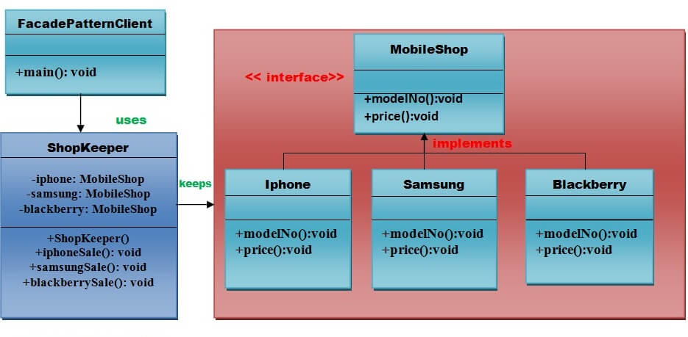

Implementation of above UML:

Step 1
Create a MobileShop interface.
File: MobileShop.java
- public interface MobileShop {
- public void modelNo();
- public void price();
- }

Step 2
Create a Iphone implementation class that will implement Mobileshop interface.
File: Iphone.java
- public class Iphone implements MobileShop {
- @Override
- public void modelNo() {
- System.out.println(" Iphone 6 ");
- }
- @Override
- public void price() {
- System.out.println(" Rs 65000.00 ");
- }
- }

Step 3
Create a Samsung implementation class that will implement Mobileshop interface.
ADVERTISEMENT
File: Samsung.java
- public class Samsung implements MobileShop {
- @Override
- public void modelNo() {
- System.out.println(" Samsung galaxy tab 3 ");
- }
- @Override
- public void price() {
- System.out.println(" Rs 45000.00 ");
- }
- }

Step 4
Create a Blackberry implementation class that will implement Mobileshop interface .
File: Blackberry.java
- public class Blackberry implements MobileShop {
- @Override
- public void modelNo() {
- System.out.println(" Blackberry Z10 ");
- }
- @Override
- public void price() {
- System.out.println(" Rs 55000.00 ");
- }
- }

Step 5
Create a ShopKeeper concrete class that will use MobileShop interface.
File: ShopKeeper.java
- public class ShopKeeper {
- private MobileShop iphone;
- private MobileShop samsung;
- private MobileShop blackberry;

- public ShopKeeper(){
- iphone= new Iphone();
- samsung=new Samsung();
- blackberry=new Blackberry();
- }
- public void iphoneSale(){
- iphone.modelNo();
- iphone.price();
- }
- public void samsungSale(){
- samsung.modelNo();
- samsung.price();
- }
- public void blackberrySale(){
- blackberry.modelNo();
- blackberry.price();
- }
- }

Step 6
Now, Creating a client that can purchase the mobiles from MobileShop through ShopKeeper.
File: FacadePatternClient.java
- import java.io.BufferedReader;
- import java.io.IOException;
- import java.io.InputStreamReader;

- public class FacadePatternClient {
- private static int choice;
- public static void main(String args[]) throws NumberFormatException, IOException{
- do{
- System.out.print("========= Mobile Shop ============ \n");
- System.out.print(" 1. IPHONE. \n");
- System.out.print(" 2. SAMSUNG. \n");
- System.out.print(" 3. BLACKBERRY. \n");
- System.out.print(" 4. Exit. \n");
- System.out.print("Enter your choice: ");

- BufferedReader br=new BufferedReader(new InputStreamReader(System.in));
- choice=Integer.parseInt(br.readLine());
- ShopKeeper sk=new ShopKeeper();

- switch (choice) {
- case 1:
- {
- sk.iphoneSale();
- }
- break;
- case 2:
- {
- sk.samsungSale();
- }
- break;
- case 3:
- {
- sk.blackberrySale();
- }
- break;
- default:
- {
- System.out.println("Nothing You purchased");
- }
- return;
- }

- }while(choice!=4);
- }
- }

Flyweight Pattern
Flyweight pattern is primarily used to reduce the number of objects created and to decrease memory footprint and increase performance. This type of design pattern comes under structural pattern as this pattern provides ways to decrease object count thus improving the object structure of application.
Flyweight pattern tries to reuse already existing similar kind objects by storing them and creates new object when no matching object is found. We will demonstrate this pattern by drawing 20 circles of different locations but we will create only 5 objects. Only 5 colors are available so color property is used to check already existing Circle objects.
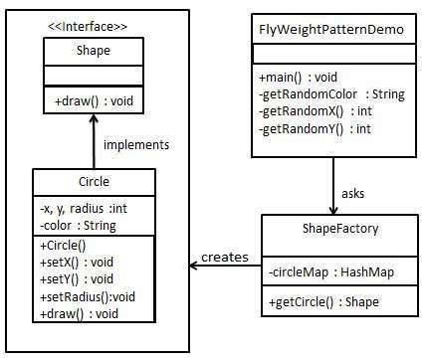

Step 1
Create an interface.
Shape.java
public interface Shape {
void draw();
}

Step 2
Create concrete class implementing the same interface.
Circle.java
public class Circle implements Shape {
private String color;
private int x;
private int y;
private int radius;

public Circle(String color){
this.color = color;
}

public void setX(int x) {
this.x = x;
}

public void setY(int y) {
this.y = y;
}

public void setRadius(int radius) {
this.radius = radius;
}

@Override
public void draw() {
System.out.println("Circle: Draw() [Color : " + color + ", x : " + x + ", y :" + y + ", radius :" + radius);
}
}

Step 3
Create a factory to generate object of concrete class based on given information.
ShapeFactory.java
import java.util.HashMap;

public class ShapeFactory {

// Uncomment the compiler directive line and
// javac *.java will compile properly.
// @SuppressWarnings("unchecked")
private static final HashMap circleMap = new HashMap();

public static Shape getCircle(String color) {
Circle circle = (Circle)circleMap.get(color);

if(circle == null) {
circle = new Circle(color);
circleMap.put(color, circle);
System.out.println("Creating circle of color : " + color);
}
return circle;
}
}

Step 4
Use the factory to get object of concrete class by passing an information such as color.
FlyweightPatternDemo.java
public class FlyweightPatternDemo {
private static final String colors[] = { "Red", "Green", "Blue", "White", "Black" };
public static void main(String[] args) {

for(int i=0; i < 20; ++i) {
Circle circle = (Circle)ShapeFactory.getCircle(getRandomColor());
circle.setX(getRandomX());
circle.setY(getRandomY());
circle.setRadius(100);
circle.draw();
}
}
private static String getRandomColor() {
return colors[(int)(Math.random()*colors.length)];
}
private static int getRandomX() {
return (int)(Math.random()*100 );
}
private static int getRandomY() {
return (int)(Math.random()*100);
}
}

Proxy Pattern
Simply, proxy means an object representing another object.
According to GoF, a Proxy Pattern "provides the control for accessing the original object".
So, we can perform many operations like hiding the information of original object, on demand loading etc.
Proxy pattern is also known as Surrogate or Placeholder.

Let's understand the example of proxy design pattern by the above UML diagram.

UML for Proxy Pattern:
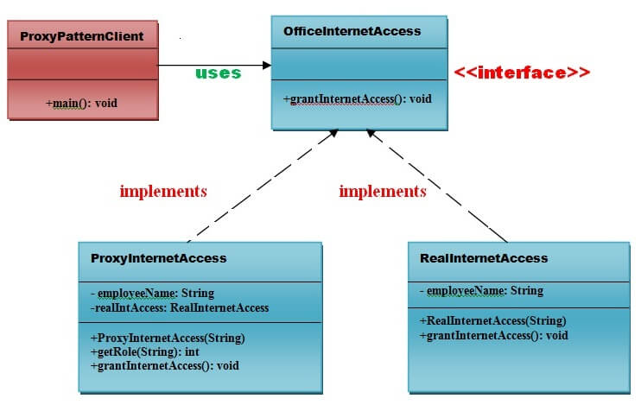

Implementation of above UML:

Step 1
Create an OfficeInternetAccess interface.
- public interface OfficeInternetAccess {
- public void grantInternetAccess();
- }

Step 2
Create a RealInternetAccess class that will implement OfficeInternetAccess interface for granting the permission to the specific employee.
File: RealInternetAccess.java
- public class RealInternetAccess implements OfficeInternetAccess {
- private String employeeName;
- public RealInternetAccess(String empName) {
- this.employeeName = empName;
- }
- @Override
- public void grantInternetAccess() {
- System.out.println("Internet Access granted for employee: "+ employeeName);
- }
- }

Step 3
Create a ProxyInternetAccess class that will implement OfficeInternetAccess interface for providing the object of RealInternetAccess class.
File: ProxyInternetAccess.java
- public class ProxyInternetAccess implements OfficeInternetAccess {
- private String employeeName;
- private RealInternetAccess realaccess;
- public ProxyInternetAccess(String employeeName) {
- this.employeeName = employeeName;
- }
- @Override
- public void grantInternetAccess()
- {
- if (getRole(employeeName) > 4)
- {
- realaccess = new RealInternetAccess(employeeName);
- realaccess.grantInternetAccess();
- }
- else
- {
- System.out.println("No Internet access granted. Your job level is below 5");
- }
- }
- public int getRole(String emplName) {
- // Check role from the database based on Name and designation
- // return job level or job designation.
- return 9;
- }
- }

Step 4
Now, Create a ProxyPatternClient class that can access the internet actually.
File: ProxyPatternClient.java
- public class ProxyPatternClient {
- public static void main(String[] args)
- {
- OfficeInternetAccess access = new ProxyInternetAccess("Ashwani Rajput");
- access.grantInternetAccess();
- }
- }

Behavioral Design Patterns

Behavioral design patterns are concerned with the interaction and responsibility of objects.
In these design patterns,the interaction between the objects should be in such a way that they can easily talk to each other and still should be loosely coupled.
That means the implementation and the client should be loosely coupled in order to avoid hard coding and dependencies.

Observer Pattern
An Observer Pattern says that "just define a one-to-one dependency so that when one object changes state, all its dependents are notified and updated automatically".

Benefits:
- It describes the coupling between the objects and the observer.
- It provides the support for broadcast-type communication.

Usage:
- When the change of a state in one object must be reflected in another object without keeping the objects tight coupled.
- When the framework we writes and needs to be enhanced in future with new observers with minimal chamges.

UML for Observer Pattern:
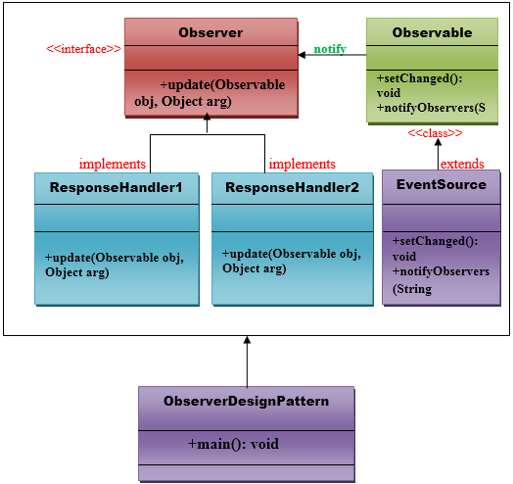

Implementation of Observer Pattern
Step 1:
Create a ResponseHandler1 class the will implement the java.util.Observer interface.
- //This is a class.

- import java.util.Observable;
- import java.util.Observer;

- public class ResponseHandler1 implements Observer {
- private String resp;
- public void update(Observable obj, Object arg) {
- if (arg instanceof String) {
- resp = (String) arg;
- System.out.println("\nReceived Response: " + resp );
- }
- }
- }// End of the ResponseHandler1 interface.
Step 2:
Create a ResponseHandler2 class the will implement the java.util.Observer interface.
- //This is a class.

- import java.util.Observable;
- import java.util.Observer;

- public class ResponseHandler2 implements Observer {
- private String resp;
- public void update(Observable obj, Object arg) {
- if (arg instanceof String) {
- resp = (String) arg;
- System.out.println("\nReceived Response: " + resp );
- }
- }
- }// End of the ResponseHandler2 interface.
Step 3:
Create an EventSource class that will extend the java.util.Observable class .
- //This is a class.

- import java.io.BufferedReader;
- import java.io.IOException;
- import java.io.InputStreamReader;
- import java.util.Observable;

- public class EventSource extends Observable implements Runnable {
- @Override
- public void run() {
- try {
- final InputStreamReader isr = new InputStreamReader(System.in);
- final BufferedReader br = new BufferedReader(isr);
- while (true) {
- String response = br.readLine();
- setChanged();
- notifyObservers(response);
- }
- }
- catch (IOException e) {
- e.printStackTrace();
- }
- }
- }// End of the Eventsource class
- .
public class ObserverPatternDemo {
public static void main(String[] args) {
System.out.println("Enter Text >");

// create an event source - reads from stdin
final EventSource eventSource = new EventSource();

// create first observer
final ResponseHandler1 responseHandler1 = new ResponseHandler1();

// subscribe the observer to the event source
eventSource.addObserver(responseHandler1);

// create second observer
final ResponseHandler2 responseHandler2 = new ResponseHandler2();

// subscribe the observer to the event source
eventSource.addObserver(responseHandler2);

// starts the event thread
Thread thread = new Thread(eventSource);
thread.start();
}
}

Chain Of Responsibility Pattern
In chain of responsibility, sender sends a request to a chain of objects. The request can be handled by any object in the chain.
A Chain of Responsibility Pattern says that just "avoid coupling the sender of a request to its receiver by giving multiple objects a chance to handle the request". For example, an ATM uses the Chain of Responsibility design pattern in money giving process.
In other words, we can say that normally each receiver contains reference of another receiver. If one object cannot handle the request then it passes the same to the next receiver and so on.

Advantage of Chain of Responsibility Pattern
- It reduces the coupling.
- It adds flexibility while assigning the responsibilities to objects.
- It allows a set of classes to act as one; events produced in one class can be sent to other handler classes with the help of composition.
Let's understand the example of Chain of Responsibility Pattern by the above UML diagram.

UML for Chain of Responsibility Pattern:
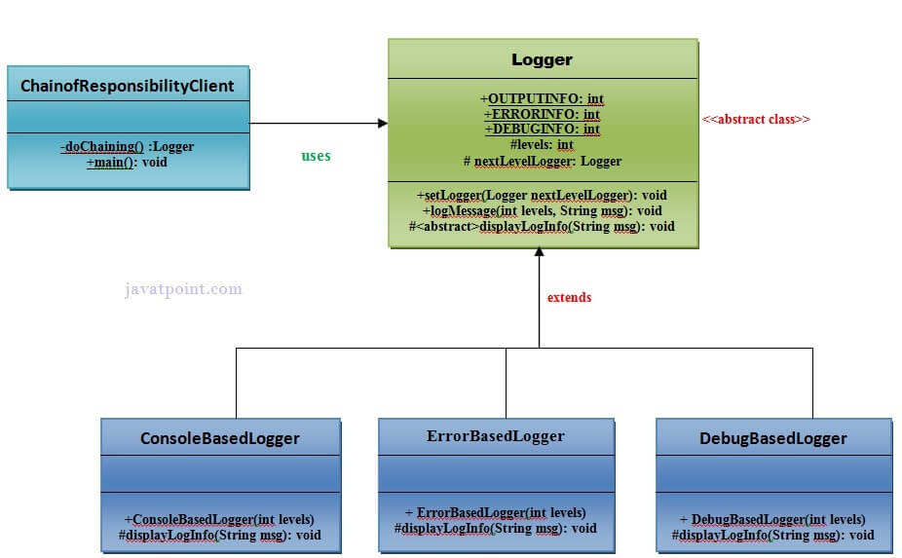

Implementation of above UML:

Step 1

// This object will contain 2 numbers and a
02 | // calculation to perform in the form of a String
03
04 | public class Numbers {
05
06 | private int number1;
07 | private int number2;
08
09 | private String calculationWanted;
10
11 | public Numbers(int newNumber1, int newNumber2, String calcWanted){
12
13 | number1 = newNumber1;
14 | number2 = newNumber2;
15 | calculationWanted = calcWanted;
16
17 | }
18
19 | public int getNumber1(){ return number1; }
20 | public int getNumber2(){ return number2; }
21 | public String getCalcWanted(){ return calculationWanted; }
22
23 | }

ADDNUMBERS.JAVA

01 | public class AddNumbers implements Chain{
02
03 | private Chain nextInChain;
04
05 | // Defines the next Object to receive the
06 | // data if this one can't use it
07
08 | public void setNextChain(Chain nextChain) {
09
10 | nextInChain = nextChain;
11
12 | }
13
14 | // Tries to calculate the data, or passes it
15 | // to the Object defined in method setNextChain()
16
17 | public void calculate(Numbers request) {
18
19 | if(request.getCalcWanted() == "add"){
20
21 | System.out.print(request.getNumber1() + " + " + request.getNumber2() + " = "+
22 | (request.getNumber1()+request.getNumber2()));
23
24 | } else {
25
26 | nextInChain.calculate(request);
27
28 | }
29
30 | }
31 | }

SUBTRACTNUMBERS.JAVA

01 | public class SubtractNumbers implements Chain{
02
03 | private Chain nextInChain;
04
05 | @Override
06 | public void setNextChain(Chain nextChain) {
07
08 | nextInChain = nextChain;
09
10 | }
11
12 | @Override
13 | public void calculate(Numbers request) {
14
15 | if(request.getCalcWanted() == "sub"){
16
17 | System.out.print(request.getNumber1() + " - " + request.getNumber2() + " = "+
18 | (request.getNumber1()-request.getNumber2()));
19
20 | } else {
21
22 | nextInChain.calculate(request);
23
24 | }
25
26 | }
27
28
29
30 | }

MULTNUMBERS.JAVA

01 | public class MultNumbers implements Chain{
02
03 | private Chain nextInChain;
04
05 | @Override
06 | public void setNextChain(Chain nextChain) {
07
08 | nextInChain = nextChain;
09
10 | }
11
12 | @Override
13 | public void calculate(Numbers request) {
14
15 | if(request.getCalcWanted() == "mult"){
16
17 | System.out.print(request.getNumber1() + " * " + request.getNumber2() + " = "+
18 | (request.getNumber1()*request.getNumber2()));
19
20 | } else {
21
22 | nextInChain.calculate(request);
23
24 | }
25
26 | }
27
28
29
30 | }

DIVIDENUMBERS.JAVA

01 | public class DivideNumbers implements Chain{
02
03 | private Chain nextInChain;
04
05 | @Override
06 | public void setNextChain(Chain nextChain) {
07
08 | nextInChain = nextChain;
09
10 | }
11
12 | @Override
13 | public void calculate(Numbers request) {
14
15 | if(request.getCalcWanted() == "div"){
16
17 | System.out.print(request.getNumber1() + " / " + request.getNumber2() + " = "+
18 | (request.getNumber1()/request.getNumber2()));
19
20 | } else {
21
22 | System.out.print("Only works for add, sub, mult, and div");
23
24 | }
25 | }
26 | }

TESTCALCCHAIN.JAVA

view source
print
?
01 | public class TestCalcChain {
02
03 | public static void main(String[] args){
04
05 | // Here I define all of the objects in the chain
06
07 | Chain chainCalc1 = new AddNumbers();
08 | Chain chainCalc2 = new SubtractNumbers();
09 | Chain chainCalc3 = new MultNumbers();
10 | Chain chainCalc4 = new DivideNumbers();
11
12 | // Here I tell each object where to forward the
13 | // data if it can't process the request
14
15 | chainCalc1.setNextChain(chainCalc2);
16 | chainCalc2.setNextChain(chainCalc3);
17 | chainCalc3.setNextChain(chainCalc4);
18
19 | // Define the data in the Numbers Object
20 | // and send it to the first Object in the chain
21
22 | Numbers request = new Numbers(4,2,"add");
23
24 | chainCalc1.calculate(request);
25
26 | }
27
28 | }

Template Pattern
A Template Pattern says that "just define the skeleton of a function in an operation, deferring some steps to its subclasses".

Benefits:
- It is very common technique for reusing the code.This is only the main benefit of it.

Usage:
- It is used when the common behavior among sub-classes should be moved to a single common class by avoiding the duplication.

UML for Template Pattern:
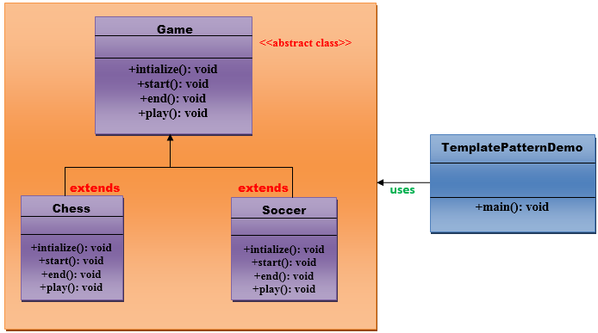

Implementation of Template Pattern:
Step 1:
Create a Game abstract class.
- //This is an abstract class.
- public abstract class Game {

- abstract void initialize();
- abstract void start();
- abstract void end();

- public final void play(){

- //initialize the game
- initialize();

- //start game
- start();

- //end game
- end();
- }
- }// End of the Game abstract class.
Step 2:
Create a Chess class that will extend Game abstract class for giving the definition to its method.
- //This is a class.

- public class Chess extends Game {
- @Override
- void initialize() {
- System.out.println("Chess Game Initialized! Start playing.");
- }
- @Override
- void start() {
- System.out.println("Game Started. Welcome to in the chess game!");
- }
- @Override
- void end() {
- System.out.println("Game Finished!");
- }
- }// End of the Chess class.
Step 3:
Create a Soccer class that will extend Game abstract class for giving the definition to its method.
ADVERTISEMENT
- //This is a class.

- public class Soccer extends Game {

- @Override
- void initialize() {
- System.out.println("Soccer Game Initialized! Start playing.");
- }

- @Override
- void start() {
- System.out.println("Game Started. Welcome to in the Soccer game!");
- }

- @Override
- void end() {
- System.out.println("Game Finished!");
- }
- }// End of the Soccer class.
Step 4:
Create a TemplatePatternDemo class.
- //This is a class.
- public class TemplatePatternDemo {

- public static void main(String[] args) throws InstantiationException, IllegalAccessException, ClassNotFoundException {

- Class c=Class.forName(args[0]);
- Game game=(Game) c.newInstance();
- game.play();
- }
- }// End of the Soccer class.

Strategy Pattern
A Strategy Pattern says that "defines a family of functionality, encapsulate each one, and make them interchangeable".

Benefits:
- It provides a substitute to subclassing.
- It defines each behavior within its own class, eliminating the need for conditional statements.
- It makes it easier to extend and incorporate new behavior without changing the application.

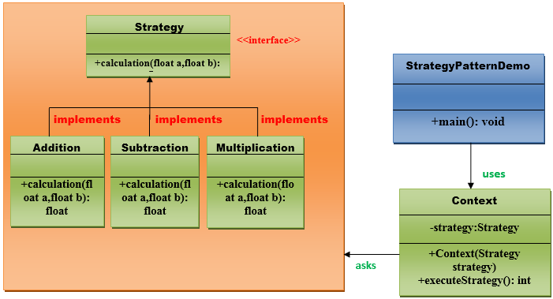

Implementation of Strategy Pattern:
Step 1:
Create a Strategy interface.
ADVERTISEMENT
- //This is an interface.

- public interface Strategy {

- public float calculation(float a, float b);

- }// End of the Strategy interface.
Step 2:
Create a Addition class that will implement Startegy interface.
- //This is a class.
- public class Addition implements Strategy{

- @Override
- public float calculation(float a, float b) {
- return a+b;
- }

- }// End of the Addition class.
Step 3:
Create a Subtraction class that will implement Startegy interface.
- //This is a class.
- public class Subtraction implements Strategy{

- @Override
- public float calculation(float a, float b) {
- return a-b;
- }

- }// End of the Subtraction class.
Step 4:
Create a Multiplication class that will implement Startegy interface.
- //This is a class.

- public class Multiplication implements Strategy{

- @Override
- public float calculation(float a, float b){
- return a*b;
- }
- }// End of the Multiplication class.
Step 5:
Create a Context class that will ask from Startegy interface to execute the type of strategy.
- //This is a class.

- public class Context {

- private Strategy strategy;

- public Context(Strategy strategy){
- this.strategy = strategy;
- }

- public float executeStrategy(float num1, float num2){
- return strategy.calculation(num1, num2);
- }
- }// End of the Context class.
Step 6:
Create a StartegyPatternDemo class.
- //This is a class.
- import java.io.BufferedReader;
- import java.io.IOException;
- import java.io.InputStreamReader;

- public class StrategyPatternDemo {

- public static void main(String[] args) throws NumberFormatException, IOException {

- BufferedReader br=new BufferedReader(new InputStreamReader(System.in));
- System.out.print("Enter the first value: ");
- float value1=Float.parseFloat(br.readLine());
- System.out.print("Enter the second value: ");
- float value2=Float.parseFloat(br.readLine());
- Context context = new Context(new Addition());
- System.out.println("Addition = " + context.executeStrategy(value1, value2));

- context = new Context(new Subtraction());
- System.out.println("Subtraction = " + context.executeStrategy(value1, value2));

- context = new Context(new Multiplication());
- System.out.println("Multiplication = " + context.executeStrategy(value1, value2));
- }

- }// End of the StrategyPatternDemo class.

